2503A52l04

**ASSIGNMENT**

Lab 7: Error Debugging with AI – Systematic Approaches to Finding and Fixing Bugs

**LAB OBJECTIVE:**

• To identify and correct syntax, logic, and runtime errors in Python programs using AI tools.

• To understand common programming bugs and AI-assisted debugging suggestions.

• To evaluate how AI explains, detects, and fixes different types of coding errors.

• To build confidence in using AI to perform structured debugging practices.

Lab Outcomes (LOs):

After completing this lab, students will be able to:

• Use AI tools to detect and correct syntax, logic, and runtime errors.

• Interpret AI-suggested bug fixes and explanations.

• Apply systematic debugging strategies supported by AI-generated insights.

• Refactor buggy code using responsible and reliable programming patterns.

**TASK1:**

**• Introduce a buggy Python function that calculates the factorial of a number using recursion. Use**

**Copilot or Cursor AI to detect and fix the logical or syntax errors.**

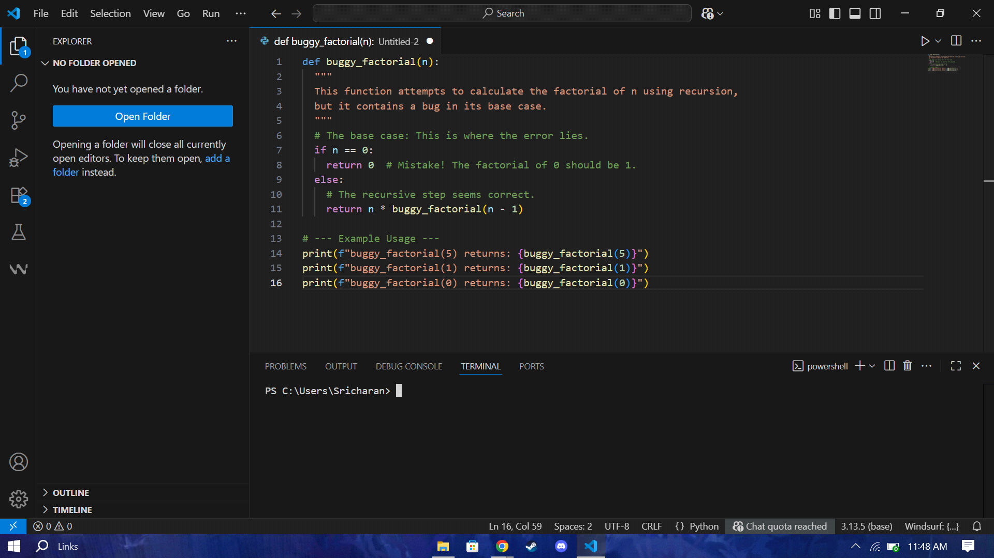

**Expected Outcome #1:**

•Copilot or Cursor AI correctly identifies missing base condition or incorrect recursive call and

suggests a functional factorial implementation

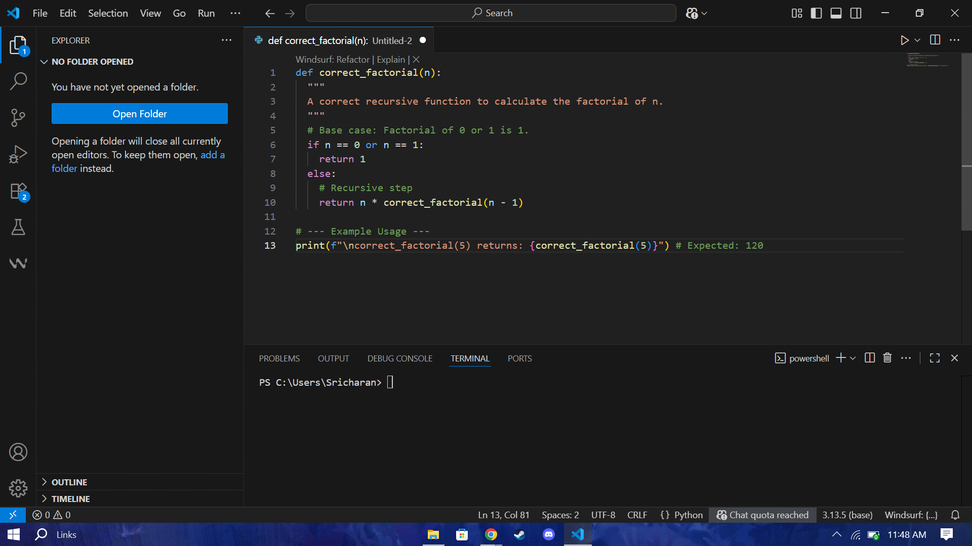

**Task Description #2:**

•Provide a list sorting function that fails due to a type error (e.g., sorting list with mixed integers

and strings). Prompt AI to detect the issue and fix the code for consistent sorting.

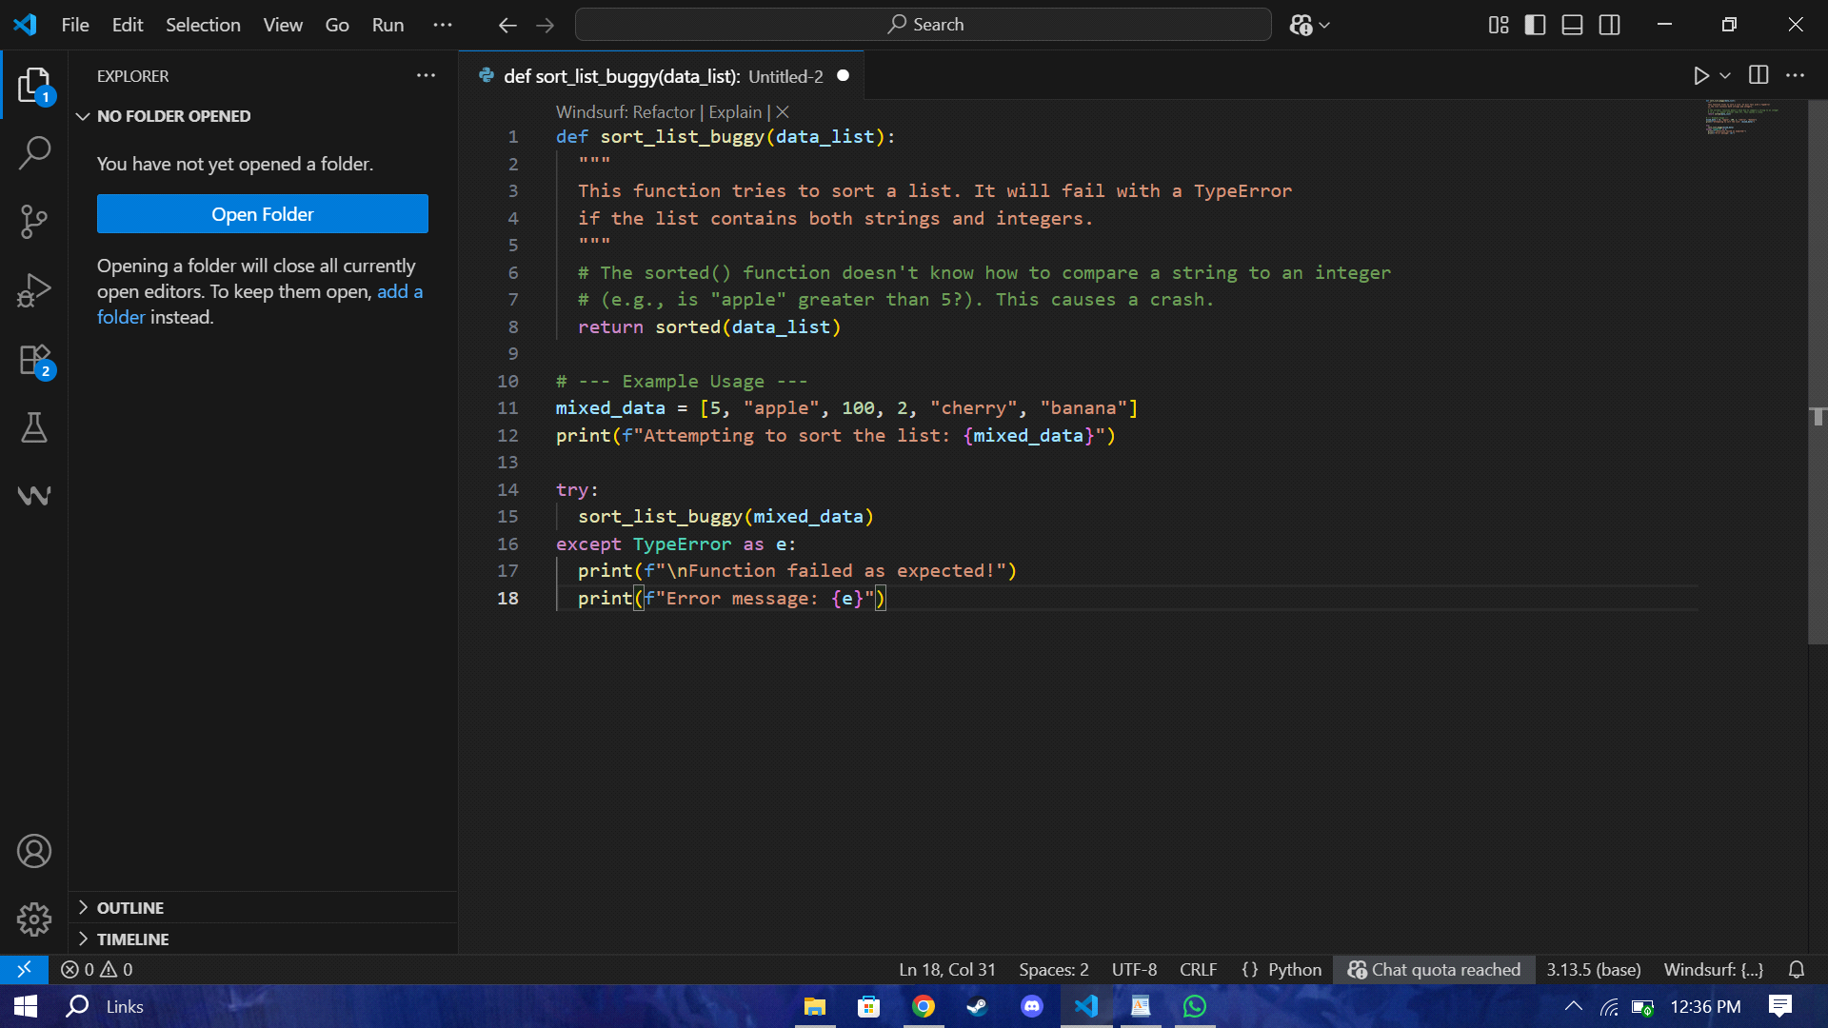

Expected Outcome #2:

•AI detects the type inconsistency and either filters or converts list elements, ensuring successful

sorting without a crash.

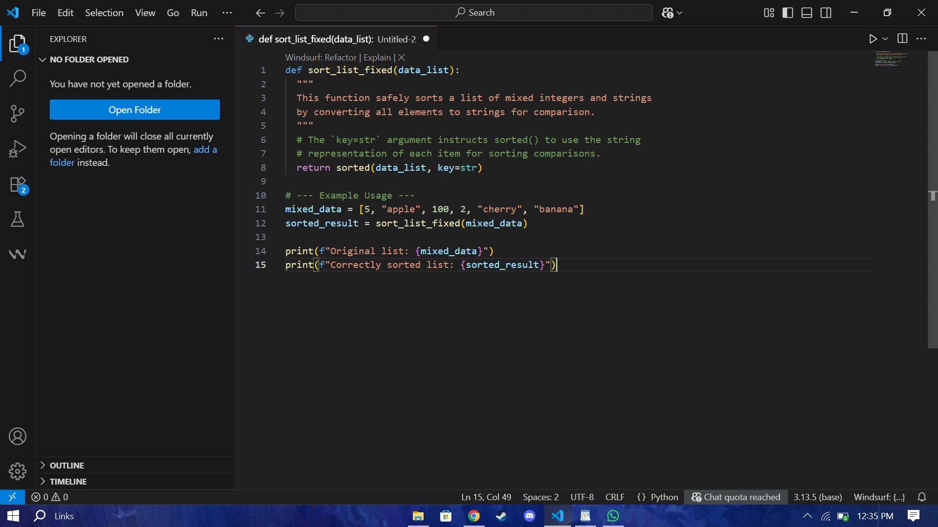

**Task Description #3:**

• Write a Python snippet for file handling that opens a file but forgets to close it. Ask Copilot or

Cursor AI to improve it using the best practice (e.g., with open() block

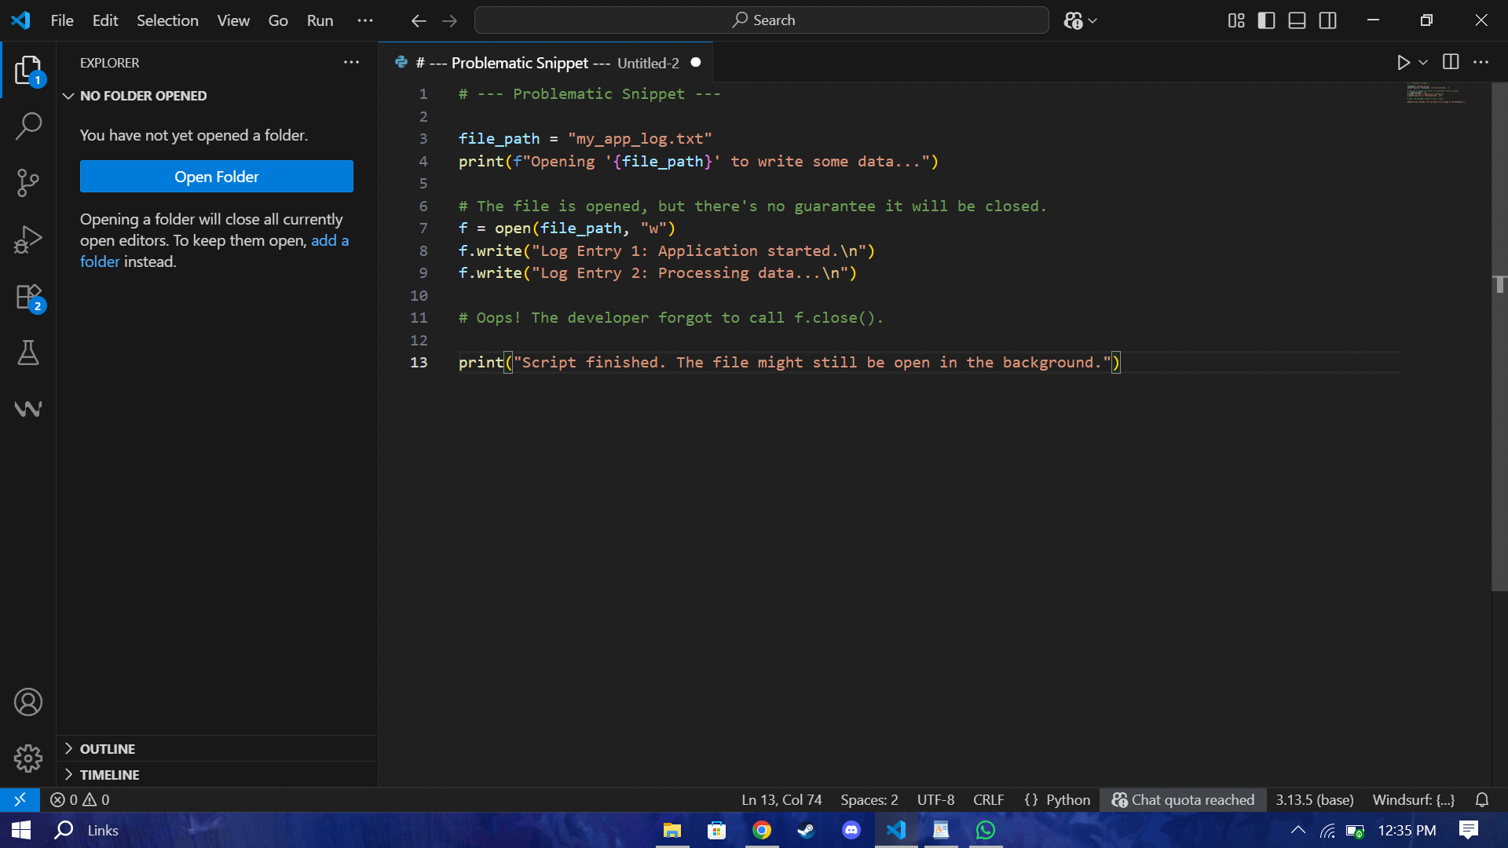

Expected Outcome #3:

• AI refactors the code to use a context manager, preventing resource leakage and runtime warnings.

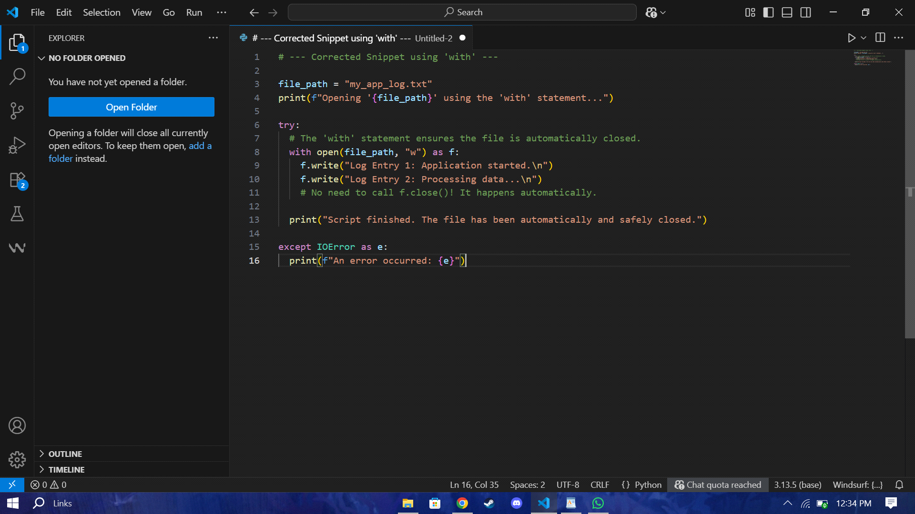

**Task Description #4:**

• Provide a piece of code with a ZeroDivisionError inside a loop. Ask AI to add error handling using

try-except and continue execution safely.

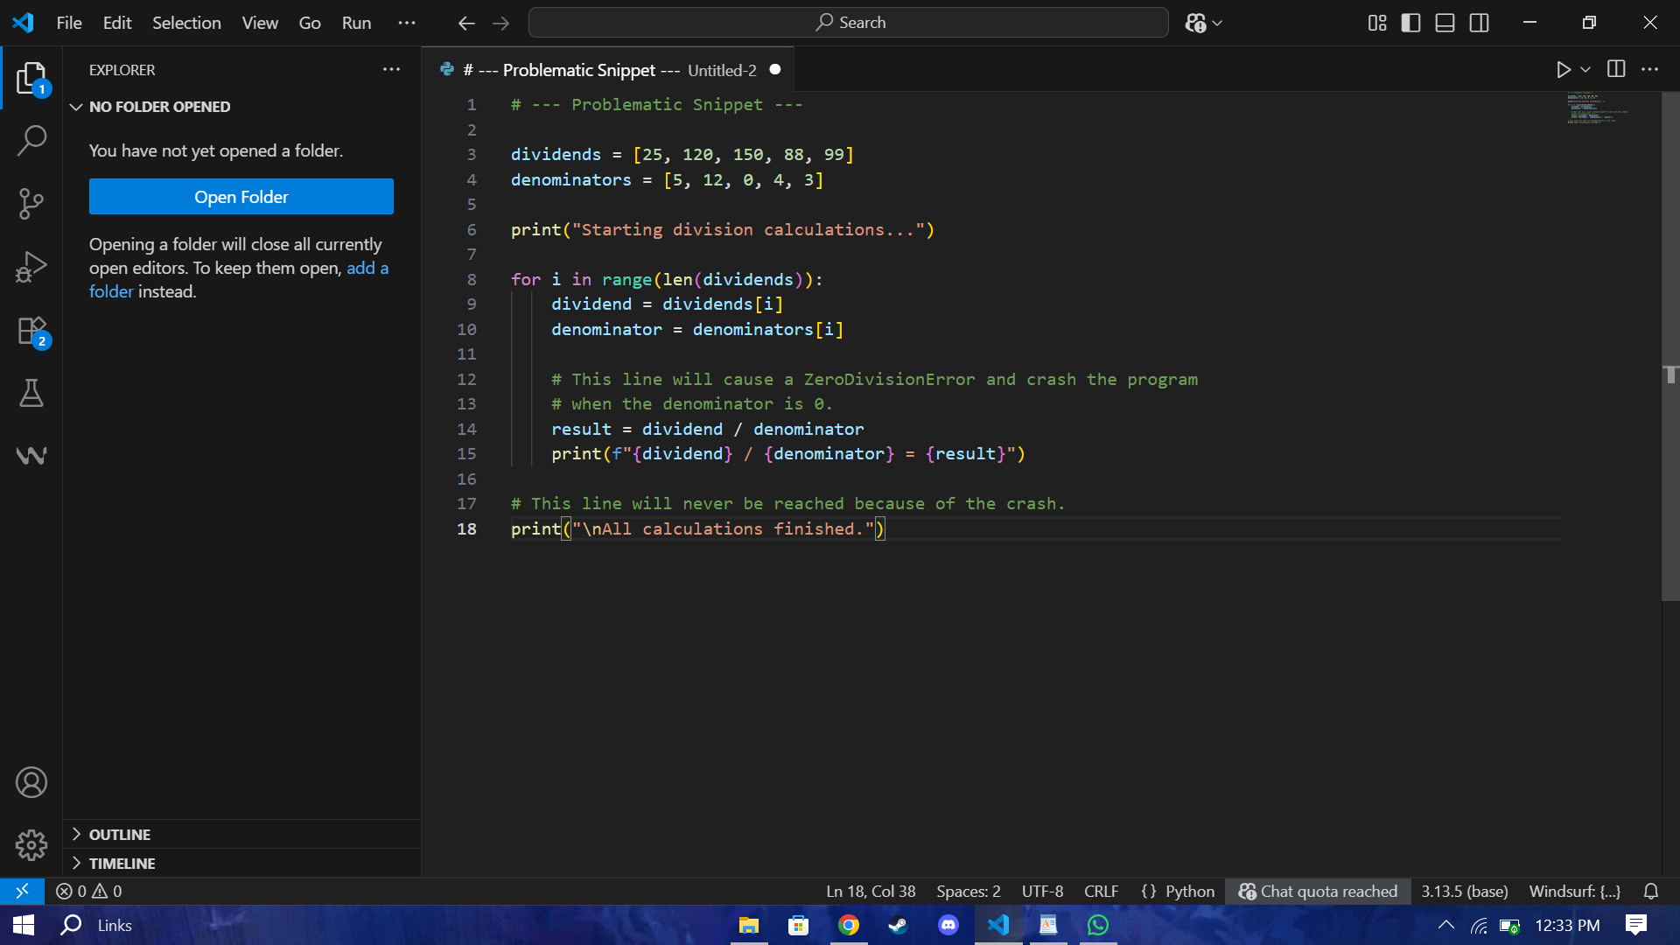

**Expected Outcome #4:**

• Copilot adds a try-except block around the risky operation, preventing crashes and printing a

meaningful error message.

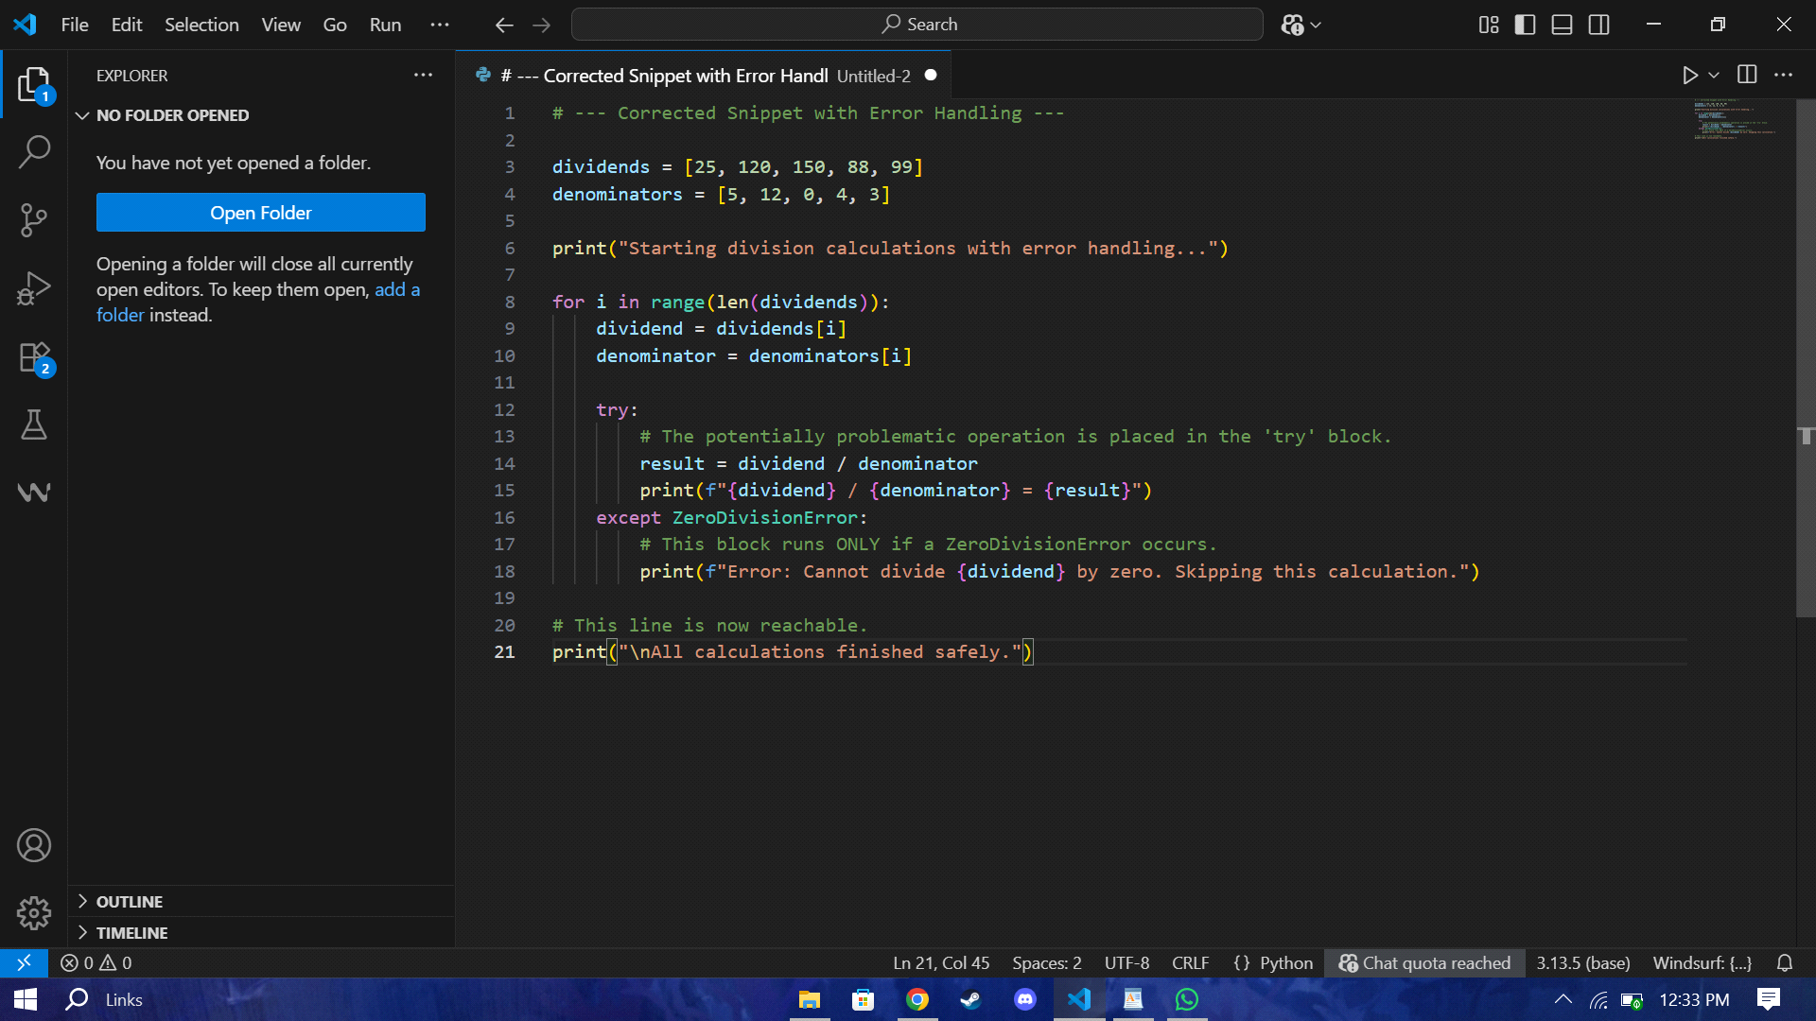

**Task Description #5:**

• Include a buggy class definition with incorrect __init__ parameters or attribute references. Ask AI

to analyze and correct the constructor and attribute usage.

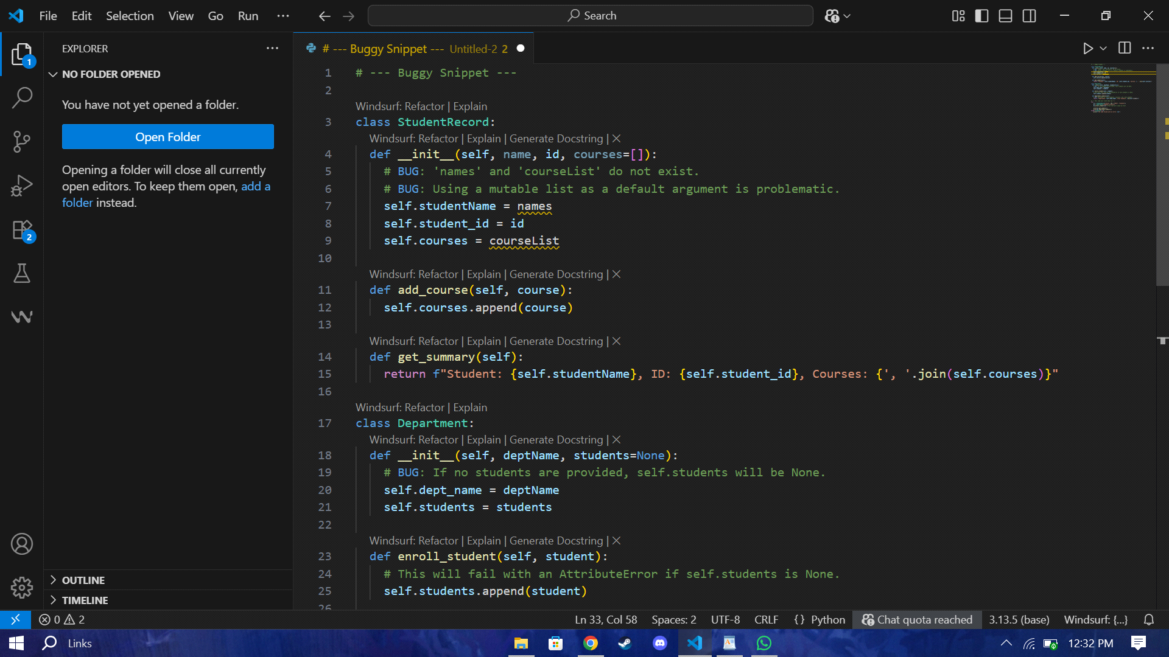

**Expected Outcome #5:**

• Copilot identifies mismatched parameters or missing self references and rewrites the class with

accurate initialization and usage.

